Annual Development Partnership Forum
29 January 2020
Scene Setter
Background
The third Annual Donor Coordination Forum will be held under the chairmanship of the Prime Minister of Georgia. The forum is aimed at enhancing the coordination of external aid provided to the country, harmonizing the assistance according to priorities of the state and strengthening the development cooperation between the Government of Georgia, authorized entities of donor countries, and international donor organizations.
Participants: Ministers, ambassadors, representatives of the international organizations, development partners and international financial institutions.
Media: the representatives of media will be invited in order to cover the event highlighting the importance of external aid provided to the country as well as success of the ongoing reforms. Government representatives as well as development partners will be interviewed
Location set-up: The theatre set up will be arranged where all the guests will be sitting. Speeches will be delivered from the Stage. PM, RC, and two ministers will be seated on stage.
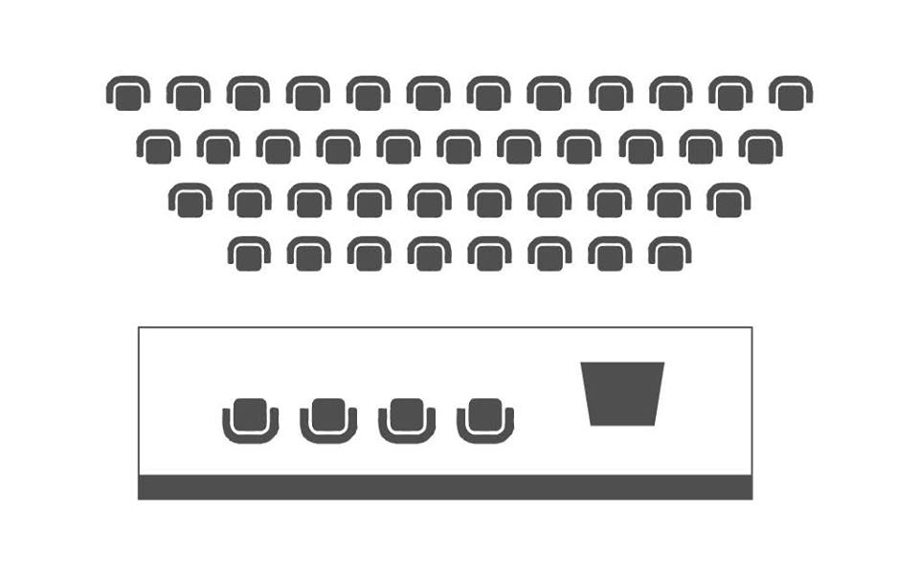
Summary
The Chairman of the Forum: Mr. Giorgi Gakharia, Prime Minister of Georgia
The Moderator: Ms. Sabine Machl, UN Resident Coordinator in Georgia
The Sequence:
- The Prime Minister of Georgia will open the event and deliver the speech.
- The Prime Minister will pass the floor to Ms. Sabine Machl, UN Resident Coordinator in Georgia to deliver the speech and take up the moderation of the first session.
- Ms. Sabine Machl will deliver the speech and pass the floor to Ministers of Finance of Georgia and Foreign Affairs of Georgia.
- After speeches are delivered, Ms. Sabine Machl will open the follow-up discussion where the following topics will be covered:

- Rule of Law, both for citizens and for the investment climate; judicial appointments; election reform in the context of development/political nexus – EU Delegation
- Ongoing civil service reform; frequent staff rotation on a management level - Germany
- “Leaving no one behind” - inclusion of civil society in decision making; gender equality and women’s representation and participation on equal terms; inclusive growth for disadvantaged groups and territories – Sweden.
The questions will be addressed by the Prime Minister, Minister of Finance and Minister of Foreign Affairs.
PM, RC, and two ministers will move to theatre seats from stage.
Discussion panels - Q&A
The first panel will be followed by one hour and ten minutes discussion that will be conducted in the format of Q&A session (without minister’s speeches). Q&A session will be moderated by relevant speakers from donor organizations, whereas the feedback will be provided by the line Ministers. For this panel seven respondent ministers will be seated on the stage and donor representatives will ask the questions from theatre seats.
Governance, Rule of Law and Justice
Ms. Sabine Machl will ask Mr. Cristian Urse, Head of COE and Ms. Thea Tsulukiani, Vice Prime Minister, Minister of Justice of Georgia to start discussion on Rule of Law and Justice. The following topics will be raised by the Moderator:
- The 4th wave of judicial reforms and their forthcoming implementation in particular with regard to judicial appointments and the new role the High School of Justice; efforts to increase judicial independence and public trust in the administration of justice.
Remark: The issue is the competence of the Parliament.
- Enforcing the anti-discrimination policy including effective investigation and adjudication of hate crimes, measures to change the perception towards minority groups, including national, religious and sexual minorities and to promote diversity as a European value.
Remark: The issue is the competence of the Prosecutor’s Office.
- Measures to foster integrity in the public sector including the fight against more complex forms of corruption.
Remark: What is the sphere of interests of donors: the work of Prosecutor’s office or Anti-corruption Agency? The issues raised during the panel discussion should be the competence of the Ministry of Justice, so that the Minister could provide comprehensive answers.

Regional Development
Mr. Cristian Urse will invite Mr. Maciej Czura, Head of EIB Regional Representation and Ms. Maya Tskitishvili, Vice Prime Minister, Minister of Regional Development and Infrastructure of Georgia to continue discussion panel. The following topics will be raised by the EIB Representative:
- Implementation of key regional development priorities and challenges in that process.
- Priorities of the core transport infrastructure development; planning, transparency and participation to reduce social conflict around infrastructure and energy projects at an early stage.
Remark: The Ministry under its competence is dealing with transportation (roads) sector in General, which is one of the main priority and will be discussed in the first part among other priorities, however transportation sector is also included in the second part as well.
The same goes to the regional development challenges in the first part, and social conflicts in the second. Since, reduction of the social conflict in infrastructure projects remains one of the main challenges in project implementation.
Furthermore, the second topic also includes energy projects. Since the Ministry of Economy and Sustainable Development of Georgia is in charge of Georgia’s energy sector, the topic should be clarified, whom the donors consider to cover this topic.

Georgia’s Economic Policy and Key Economic Reforms
Mr. Maciej Czura will pass the floor to Mr. Sebastian Molineus, WB Regional Director and Ms. Natia Turnava, Minister of Economy and Sustainable Development of Georgia. The development partners are committed to support Georgia’s economic development and see opportunities in the following areas:
- Strengthening the foundations for growth and jobs along four key areas: i) Leveling and improving the playing field; ii) Enhancing competitiveness; iii) Increasing human capital and iv) Stronger resilience. On all this, the use of digital technologies can be transformational.
- Setting the stage for the economy of the future, integrated and connected, green and resilient, knowledge-based, and digital. As the current strategy nears its completion, is this a good time to start the thinking on a new comprehensive, ambitious, yet realistic vision for the country?
- Improving the effectiveness of our support. An “outcome driven” approach to donor coordination by the government in support of a well-defined government reform agenda can achieve better outcomes. This could mean creating a few platforms in key sectors (e.g. education, energy, connectivity, etc.), with agreed upon targets and a select number of DPs working hand-in-hand with the government.
Human Capital Development
Mr. Sebastian Molineus will invite for discussion Mr. Vincent Rey, Head of Cooperation of EUD and Ms. Irina Abuladze, Deputy Minister of Education, Science, Culture and Sport of Georgia. The topic of discussion are:
- Roll out of Education strategy in a way that secures the necessary long- term quality and continuity (policy, budget and staff) and comprehensive coverage of bottlenecks.
- Achieving results in vocational education and training (VET) and making sure that labour market policy matches skills and jobs.
- Creating conditions to encourage and incentivize the companies to invest in research and innovation.
Environmental Protection and Agriculture
Mr. Vincent Rey will pass the floor to H.E. Hubert Knirsch, Ambassador of Germany and Mr. Levan Davitashvili, Minister of Environmental Protection and Agriculture of Georgia. The following topics will be discussed:
- Anchoring climate change as a cross-cutting topic in all relevant sectors including energy efficiency and ministries. Availability of resources (financial and human) for the forest sector reforms.
- Stimulating land consolidation and technological modernization in agriculture; increase productivity, access to finance and competitiveness.
Social Welfare
H.E. Hubert Knirsch will invite for further discussion H.E. Petr Mikyska, Ambassador of Czech Republic and Ms. Ekaterine Tikaradze, Minister of Internally Displaced Persons from the Occupied Territories, Labour, Health and Social Affairs of Georgia. Topic for discussion are:
- Improving health outcomes and addressing current challenges of the health care system.
- Quality of post-graduate and continuous medical education programmes; certification of medical doctors.
- Improvement of the effectiveness of the social protection model.
Conflict Prevention and Resolution
H.E. Petr Mikyska will pass the floor to Mr. Peter Wiebler, USAID Mission Director and Ms. Ketevan Tsikhelashvili, State Minister for Reconciliation and Civic Equality in Georgia for the last discussion. The following topics will be discussed:
- Reconciliation with the occupied regions.
- Integration (civic, economic and political) of minorities within Tbilisi-administered territory.
- Development partner intervention analysis in the occupied regions; identifying effective methods.
Closing of the Discussions Panels
Ms. Sabine Machl, UN Resident Coordinator in Georgia will sum up and close the discussion panels.

